A000-AM,S-Bolivia-Titicaca Lake-Tiwanaku Tiahuanaco-Bone Amulet-500 CE



Bolivia-Titicaca Lake-Tiwanaku-Tiahuanaco-Bone Amulet depicting Viracocha-500 CE

Case No.: 9

**Accession No.**

**Formal Label:** Bolivia-Titicaca Lake-Tiwanaku Tiahuanaco-Bone Amulet-500 CE

**Display Description:**

The site of Tiwanaku was first recorded by Pedro Cieza de León in 1549 while searching for the Inca capital (Kolata 1993).

.

Doorway god and accompanying “angels” on the Gateway of the Sun at Tiwanaku. The main figure has been variously described as a sun god, a thunder god, or Viracocha. Georg Gerster—Rapho/Photo Researchers

 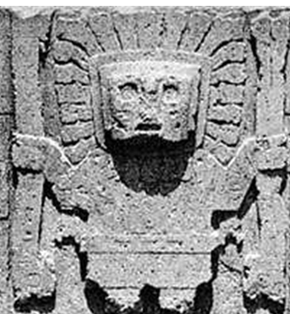

Fig. 1, Viracocha engraved on a bone phalange. His headdress towers above his face, while his hands are depicted as horizontal lines below and his platform is depicted as diamonds below that. Fig. 2 Viracocha from the Gateway of the Sun at Tiwanaku, standing in a frontal pose, wearing the sun for a crown, and grasping feline-headed thunderbolts in each hand. Viracocha as the Sun is the substance from which all things are created according to Dominican Friar Bartolomé de las Casas (1484–1566). It was believed that the use of Viracocha as an amulet would protect the wearer from illness and disease and would ensure a productive life.

**LC Classification:**

**Date or Time Horizon:**

**Geographical Area:**

**Map:**

**GPS coordinates:**

**Cultural Affiliation:**

**Media:**

**Dimensions:** 2.52 in, 6.4 cm

**Weight:**

**Condition:**

**Provenance:**

**Discussion:**

Since the ancient inhabitants of Tiwanaku had no written language their name for the site is unknown, but they are believed to have spoken the Puquina language. The extent of the influence of the Tiwanaku culture including its Viracochan spirituality may be inferred from the diffusion of the Puquina language.

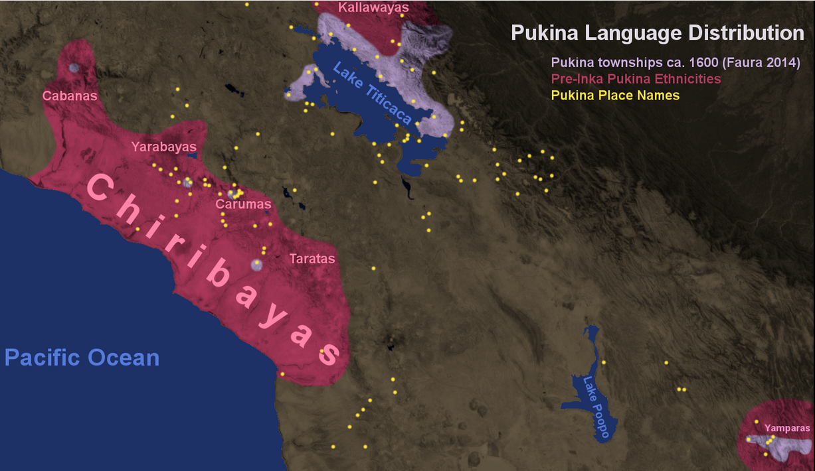

Pukina language distribution around 1600 CE, Pukina toponyms, and pre-Inca Pukina ethnicities. After

[Hangmanwa7id](https://commons.wikimedia.org/w/index.php?title=User:Hangmanwa7id&action=edit&redlink=1)  **9 Sept. 2015.**

**References:**

Kolata, Alan L. (December 11, 1993). The Tiwanaku: Portrait of an Andean Civilization. Wiley-Blackwell.